A

Project Report

On

**Hospital Management System**

Developed by

**Patel Ketul-Department of IT, DD University**

**Patel Manan-Department of IT, DD University**

**Guided By**

**Prof. Sunil K. Vithlani**

**Department of Information Technology**

**Faculty of Technology**

**DD University**



**Department of Information Technology**

**Faculty of Technology, Dharmsinh Desai University**

**College Road, Nadiad-387001**

**October-2019**

## DHARMSINH DESAI UNIVERSITY

## NADIAD-387001, GUJARAT



## CERTIFICATE

### This is to certify that the project entitled “Hospital Management System” is a bonafied report of the work carried out by

1) Mr. Ketul Patel, Student ID No: 17ITUOS105

2) Mr. Manan Patel, Student ID No: 17ITUON029

of Department of Information Technology, semester V, under the guidance and supervision for the subject Database Management System. They were involved in Project training during academic year 2019-2020.

Prof. Sunil K. Vithlani

Department of Information Technology,

Faculty of Technology,

Dharmsinh Desai University, Nadiad

Date:

Prof. Vipul Dabhi

Head, Department of Information Technology,

Faculty of Technology,

Dharmsinh Desai University, Nadiad

Date:

**ACKNOWLEDGEMENT**

I would like thank to all those who are involved in this endeavor for their kind cooperation for its successful completion. At the outset, I wish to express my sincere gratitude to all those people who have helped me to complete this project in an efficient manner.

I offer my special thanks to my Project Guide **Prof. Sunil Vithlani**, Assistant Professor, Department of Information Technology, Dharmsinh Desai University, Nadiad without whose help and support throughout this project would not have been this success.

I would like to thanks **Dr.Vipul Dabhi** Head, Department of Information Technology, Dharmsinh Desai University, who gave opportunity to do this project at an extreme organization. Most of all and more than ever, I would like to thanks my family members for their warmness, support, encouragement, kindness and patience. I am really thanks to all my friends who always advice and motivated me throughout the project.

Yours sincerely,

Ketul Patel (IT-082)

Manan Patel (IT-083)

# TABLE OF CONTENTS

**I. Certificate 1**

**II. Acknowledgement 3**

**1. SYSTEM OVERVIEW 5**

1.1 Current system 5

1.2 Objectives of the Proposed System 5

1.3 Advantages of the Proposed system (over current)……………………………...6

**2. E-R DIAGRAM 8**

2.1 Entities………………………………………………………………………….8

2.2 Relationships……………………………………………………………............10

2.3 Mapping Constraints……………………………………………………………10

**3. DATA DICTIONARY 11**

**4. SCHEMA DIAGRAM 13**

**5. DATABASE IMPLEMENTION 14**

5.1 Create Schema 14

5.2 Insert Data values 19

5.3 Queries (Based on functions, group by, having, joins, sub query etc.) 32

5.4 Exception……………………………………………………………………..35

5.4 Functions 37

5.5 Procedures 39

5.6 Triggers 42

5.7 Cursors. 45

**6. FUTURE ENHANCEMENTS OF THE SYSTEM 48**

**7. BIBLIOGRAPH……………………………………………………………….....49**

1. **SYSTEM OVERVIEW**

**1.1 CURRENT SYSTEM:**

The Hospital Management system or the hospital billing software incorporates the features which are targeted at dealing with each and every aspects of any hospital and this software also covers the areas like OPD, reception, outpatients, inpatients, inventory of the materials and the medicines, medical records, scheduling of the duties of the doctors, appointments, accounts and laboratories. Besides, this software also offers the security feature that prevents the stored information of the hospitals from getting misused.

The common features of this type of software are:

* This software facilitates complete and smooth running of the reception
* It manages all the bed allocation systems and the wards of the hospitals
* It manages the laboratory and the equipments.
* It manages the treatments as well as the entire history of the patients
* This software manages the day to day scheduling of both the nurses and the doctors to various departments and also allocates the schedules of their duties
* This software manages the management with the timely and regular refurbishment of stocks of the instruments and the medicines
* It also manages the timely and proper accounting to make sure a proper and current billing
* The hospital management software also maintains the proper tests of a number of patients as well as keeps the records of all the medical reports
* The biggest benefit of the hospital management system is that it can be used at the same time via a number of users.
  1. **OBJECTIVES OF PROPOSED SYSTEM:**

Main objectives of a [Hospital Management System](http://www.datamateuae.com/) are:

* Design a system for better patient care.
* Reduce hospital operating costs.
* Provide top management a single point of control.

[Hospital management System](http://www.datamateuae.com/) handles activities of major departments in a hospital like:

1. Front Office/OPD Management

2. Patient management (scheduling, registration and long-term care)

3. Patient care management and departmental modules (radiology, pharmacy and pathology labs)

4. Investigative Labs

5. Billing

6. Medical Stores

7.Financial Accounting (billing, insurance processing, materials management, accounts payable/receivable, payroll and general ledger)

8. Payroll

Hospital management system can be developed by using [waterfall model](http://www.datamateuae.com/)which is a popular version of [development life cycle model](http://www.datamateuae.com/)for [software engineering](http://www.datamateuae.com/). It describes a development method that is linear and sequential. It has distinct goals for each phase of development. In this model once, a phase of development is completed, there is no turning back, the development proceeds to the next phase. The advantage of this model is that it allows for departmentalization and managerial control.

* 1. **ADVANTAGES OF PROPOSED SYSTEM**

1. Easy Access to Patient Data:-

A well-implemented [Hospital Management System](http://attunelive.com/hospital-information-system/) means readily available patient data to the care providers. It is only a matter of few clicks and all the requisite information about a patient, from various departments in the hospital, can be available on the screen. If the treating doctor needs to re-check the test reports of a patient, she need not go looking for the IPD file; logging into the HMS will give her instant access to those reports and timely treatment decisions ensue.

2. Cost Effective:-

HMS, when implemented well, cuts out on a lot of manual work that are essentially performed in hospitals, especially the ones where documentation and record keeping is required. It helps in cutting down manpower because a lot of work gets automated and does not require manual intervention to store or analyze the information. It also saves much on storage and the related costs.

3. Improved Efficiency

Processes [automated](http://attunelive.com/hospital-information-system-benefits/) using software would mean that the processes will be taken care of mechanically without any human intervention and this will instantly ensure improved efficiency. The software will not face human problems like fatigue, miscommunication or lack of focus; it will perform every task assigned to it with the same accuracy day in and day out.

4. Reduces Scope of Error

Because processes on HMS are automated and a lot of tasks are assigned to the software to perform with utmost accuracy with minimum human intervention, the scope of error is reduced dramatically. For instance, while billing an IDP patient for the drugs used with HMS, the bill can hardly go wrong because the drug the nurse indents is what is billed for until and unless there is a shortage in stock or change in drug order after the indent has been sent. Per unit rate of the drug is saved in the software as part of standard operating procedure of automation. Just selecting the drug name and the quantity will enable the software to calculate the amount due, accurately.

5. Increased Data Security & Retrieve-ability

Record keeping in hospitals is a mandatory bane with two challenges: keeping the data safe with only authorized personnel getting access to it and retrieving it in the minimum possible time. Add to these the perennial problems of space shortage, protection from natural elements and protection from pest damage etc.

HMS is the perfect solution for these problems. All the data is stored on the server or cloud, keeping it safe. Since HMS works on logins, data security is becomes a non-issue offering data access based on the role of the person – Receptionist, doctor, nurse, radiologist etc. Retrieve-ability of data stored on a server or cloud is only a matter of few clicks and the data will appear on the screen within seconds.

**2. E-R DIAGRAM**

**2.1 ENTITIES:**

1. Patient-> This entity represents the information about the Patients which were admitted in the Hospital.

The attributes of the Patient are

* P_Id
* P_Name
* P_Mobile
* P_Address
* P_City
* P_Age
* P_Gender
* P_Email
* P_AdmitDate
* P_DischagreDate
* P_Diseases
* D_Id
* R_Id

1. Doctor-> This entity represents the information about the doctors which are employed in the Hospital.

The attributes of the Doctor are

* + - * D_Id
      * D_Name
      * D_Mobile
      * D_Address
      * D_Age
      * D_Gender
      * D_Salary
      * D_Qualification
      * D_JoinDate

1. Rooms-> This entity represents the information about the rooms which are available in the Hospital.

The attributes of the Rooms are

* R_Id
* R_Type
* R_Floor
* R_Cost

1. Employee-> This entity represents the information about the employees which working in the Hospital.

The attributes of the Employee are

* E_Id
* E_Name
* E_Mobile
* E_Address
* E_Age
* E_Gender
* E_Salary
* E_JoinDate
* E_Duration

1. Accounts-> This entity represents the information about the accounts of a doctor and the employee.

The attributes of the Accounts are

* A_Bill_No
* Date_Of_Payment
* Total_Days
* Total_Cost

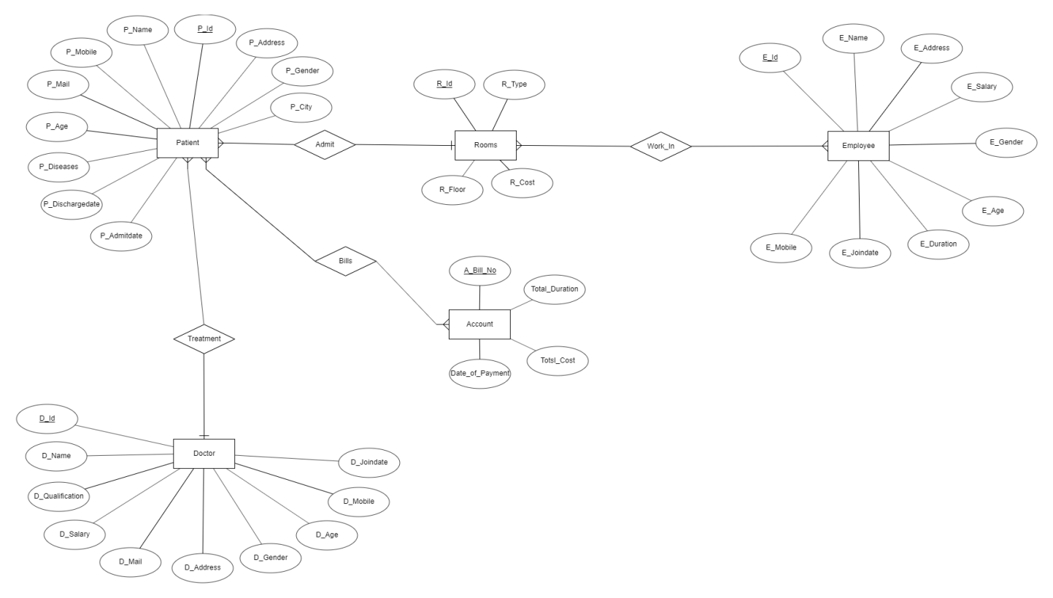

* 1. **RELATIONSHIPS:**

1. Works_In-> This entity represents the information about the employee which are working in a which particular room.

The attributes of the Rooms are

* + - * + R_Id
        + E_Id

1. Billls-> This entity represents the information about the account bill number for a particular patient id.

The attributes of the bills are

* + - * + A_Bill_No
        + P_Id

**2.3 MAPPING CONSTRAINTS:**

* There is Many to One relationship between Patient and Rooms as there can be multiple patients in a one room.
* There is Many to One relationship between Doctor and Patient as there can be multiple patients under one doctor.
* There is Many to Many relationship between Employee and Rooms as one Room can have multiple employees working and one Employee can work for multiple Rooms.
* There is Many to Many relationship between Patient and Account as one patient can have multiple bills and multiple bills should belong to one Patient.

.

**3. DATA DICTIONARY**

* Patient

|  |  |  |  |
| --- | --- | --- | --- |
| **NAME** | **DATA** **TYPE** | **SIZE** | **CONSTRAINTS** |
| P_Id | Varchar2 | 5 | Primary Key |
| P_Name | VarChar2 | 30 |  |
| P_Mobile | Number | 10 |  |
| P_Address | VarChar2 | 50 |  |
| P_City | VarChar2 | 20 |  |
| P_Age | Number | 38 |  |
| P_Gender | VarChar2 | 10 |  |
| P_Email | Varchar2 | 30 |  |
| P_AdmitDate | Date | 7 |  |
| P_DischageDate | Date | 7 |  |
| P_Diseases | Varchar2 | 30 |  |
| D_Id | Varchar2 | 5 | Foreign Key |
| R_Id | Varchar2 | 5 | Foreign Key |

* Doctor

|  |  |  |  |
| --- | --- | --- | --- |
| **NAME** | **DATA** **TYPE** | **SIZE** | **CONSTRAINTS** |
| D_Id | Varchar2 | 5 | Primary Key |
| D_Name | VarChar2 | 30 |  |
| D_Mobile | Number | 10 |  |
| D_Address | VarChar2 | 50 |  |
| D_Mail | VarChar2 | 20 |  |
| D_Age | Number | 38 |  |
| D_Gender | VarChar2 | 10 |  |
| D_Salary | Number | 10 |  |
| D_Qualification | VarChar2 | 20 |  |
| D_JoinDate | Date | 7 |  |

* Bills

|  |  |  |  |
| --- | --- | --- | --- |
| **NAME** | **DATA TYPE** | **SIZE** | **CONSTRAINTS** |
| A_Bill_No | VarChar2 | 10 | Foreign Key |
| P_Id | VarChar2 | 5 | Foreign Key |

* Rooms

|  |  |  |  |
| --- | --- | --- | --- |
| **NAME** | **DATA TYPE** | **SIZE** | **CONSTRAINTS** |
| R_Id | VarChar2 | 5 | Primary Key |
| R_Type | VarChar2 | 10 |  |
| R_Floor | Number | 10 |  |
| R_Cost | Number | 10 |  |

* Emloyee

|  |  |  |  |
| --- | --- | --- | --- |
| **NAME** | **DATA** **TYPE** | **SIZE** | **CONSTRAINTS** |
| E_Id | Varchar2 | 5 | Primary Key |
| E_Name | VarChar2 | 30 |  |
| E_Mobile | Number | 10 |  |
| E_Address | VarChar2 | 50 |  |
| E_Age | Number | 10 |  |
| E_Gender | VarChar2 | 10 |  |
| E_Salary | Number | 10 |  |
| E_JoinDate | Date | 7 |  |
| E_Duration | Number | 10 |  |

* Works_In

|  |  |  |  |
| --- | --- | --- | --- |
| **NAME** | **DATA TYPE** | **SIZE** | **CONSTRAINTS** |
| R_Id | VarChar2 | 5 | Foreign Key |
| E_Id | VarChar2 | 5 | Foreign Key |

* Accounts

|  |  |  |  |
| --- | --- | --- | --- |
| **NAME** | **DATA TYPE** | **SIZE** | **CONSTRAINTS** |
| A_Bill_No | VarChar2 | 5 | Primary Key |
| Date_of_Payment | Date | 7 |  |
| Total_Days | Number | 38 |  |
| Total_Cost | Number | 10 |  |

**4. SCHEMA DIAGRAM**

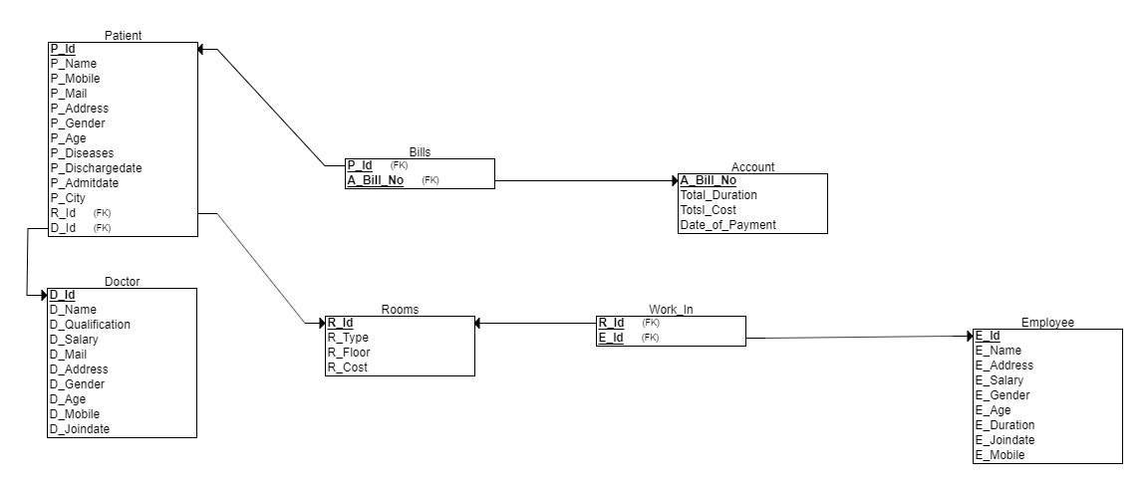

**5. DATABASE IMPLEMENTATION**

**5.1 CREATE SCHEMA:**

1. PATIENT:-

CREATE TABLE Patient(

P_Id VARCHAR(5) NOT NULL,

P_Name VARCHAR(30) NOT NULL,

P_Mobile NUMBER(10),

P_Address VARCHAR(50) NOT NULL,

P_City VARCHAR(20) NOT NULL,

P_Age NUMBER(38) NOT NULL,

P_Gender VARCHAR(10) NOT NULL,

P_Email VARCHAR(30),

P_AdmitDate DATE NOT NULL,

P_DichargeDate DATE,

P_Diseases VARCHAR(30) NOT NULL,

D_Id VARCHAR(5),

R_Id VARCHAR(5),

FOREIGN KEY (D_Id) REFERENCES Doctor(D_Id),

FOREIGN KEY (R_Id) REFERENCES Rooms(R_Id),

PRIMARY KEY(P_id)

);

DESC TABLE PATIENT

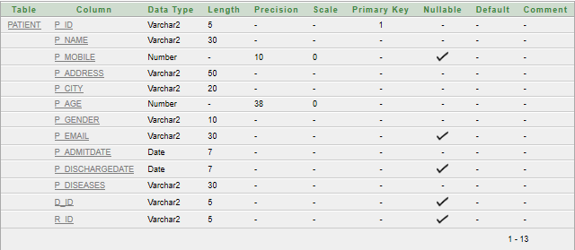

1. DOCTOR:-

CREATE TABLE Doctor(

D_Id VARCHAR(5) NOT NULL,

D_Name VARCHAR(30) NOT NULL,

D_Mobile NUMBER(10) NOT NULL,

D_Address VARCHAR(50) NOT NULL,

D_Mail VARCHAR(20) NOT NULL,

D_Age NUMBER(38) NOT NULL,

D_Gender VARCHAR(10) NOT NULL,

D_Salary NUMBER(10) NOT NULL,

D_Qualification VARCHAR(20) NOT NULL,

D_JoinDate DATE NOT NULL,

PRIMARY KEY(D_id)

);

DESC TABLE DOCTOR

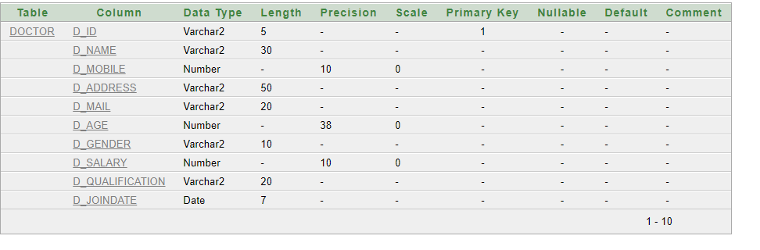

1. BILLS:-

CREATE TABLE Bills(

A_Bill_No VARCHAR(10) NOT NULL,

P_Id VARCHAR(5) NOT NULL,

FOREIGN KEY(P_Id) REFERENCES Patient(P_Id),

FOREIGN KEY(A_Bill_No) REFERECES Account(A_Bill_No)

);

DESC TABLE BILLS

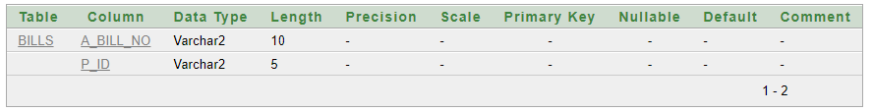

1. ROOMS:-

CREATE TABLE Rooms(

R_Id VARCHAR(5) NOT NULL,

R_Type VARCHAR(10) NOT NULL,

R_Floor NUMBER(10) NOT NULL,

R_Cost NUMBER(10),

PRIMARY KEY(R_id)

);

DESC TABLE ROOMS

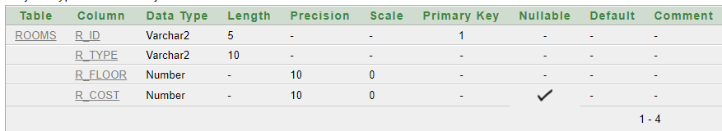

1. EMPLOYEE

CREATE TABLE Employee(

E_Id VARCHAR(5) NOT NULL,

E_Name VARCHAR(30) NOT NULL,

E_Mobile NUMBER(10) NOT NULL,

E_Address VARCHAR(50) NOT NULL,

E_Age NUMBER(10) NOT NULL,

E_Gender VARCHAR(10) NOT NULL,

E_Salary NUMBER(10) NOT NULL,

E_JoinDate DATE NOT NULL,

E_Duration NUMBER(10),

PRIMARY KEY(E_Id)

);

DESC TABLE EMPLOYEE

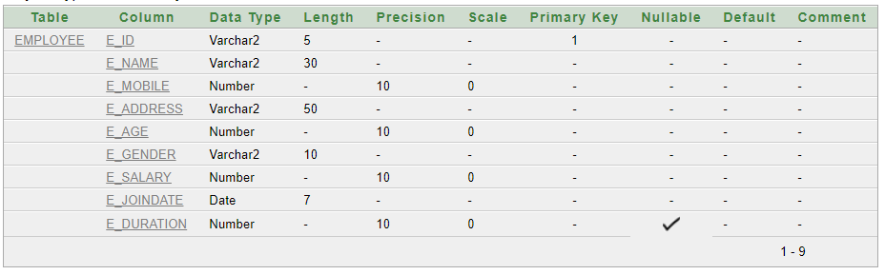

1. ACCOUNTS:-

CREATE TABLE Accounts(

A_Bill_No VARCHAR(10) NOT NULL,

Date_Of_payment DATE NOT NULL,

Total_Days NUMBER(38),

Total_Cost NUMBER(10),

PRIMARY KEY(A_Bill_No)

);

DESC TABLE ACCOUNTS

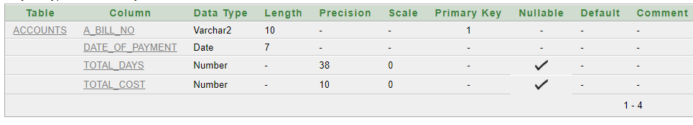

1. WORKS_IN:-

CREATE TABLE WORKS_IN(

R_Id varchar2(5),

E_Id varchar2(5),

FOREIGN KEY(R_Id) REFERENCES Rooms(R_Id),

FOREIGN KEY(E_Id) REFERENCES Employee(E_Id)

);

DESC TABLE WORKS_IN

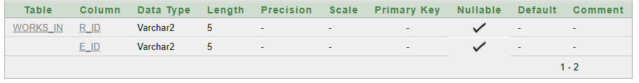

**5.2 INSERT DATA VALUES:**

1. PATIENT:

INSERT INTO Patient

VALUES('P_1','MANAN PATEL',9428661125,'GANESHPURI SOCIETY','AHMEDABAD',20,'MALE',mananpatel123@gmail.com,'10-AUG-2018','20-DEC-2018','Heart Cancer','D_1','R_1');

INSERT INTO Patient

VALUES('P_2','KETUL PATEL',9765238638,'GANESH SOCIETY','SURAT',25,'MALE','ketulpatel456@gmail.com','30-DEC-2018','15-MAR-2019','Chronic Kideny Disease','D_2','R_2');

INSERT INTO Patient

VALUES('P_3','BHAVIKA SHARMA',9876534567,'AVADH SOCIETY','VADODARA',10,'FEMALE','bhavikasharma12@gmail.com','10-MAY-2018','30-JAN-2019','Brain Tumor','D_2','R_2');

INSERT INTO Patient

VALUES('P_4','MEET CHAROLA',5678987654,'RAVI SOCIETY','PUNE',15,'MALE','meetcharola1@gmail.com','10-OCT-2018','20-NOV-2018','AIDS','D_3','R_3');

INSERT INTO Patient

VALUES('P_5','VISHWA VYAS',1234509876,'SHREE SOCIETY','MUMBAI',30,'FEMALE','vishwavyas789@gmail.com','10-JAN-2018','25-JUN-2019','Bone Fracture','D_4','R_4');

INSERT INTO Patient

VALUES('P_6','SETUL PATEL',7865433326,'AASTHA EMRALD','AHMEDABAD',22,'MALE','setulpatel712@gmail.com','10-MAY-2018','25-FEB-2019','Tuber Culosis','D_5','R_6');

INSERT INTO Patient

VALUES('P_7','MEETRAJSINH',7654259977,'ISHAN RESIDENCY','BHOPAL',25,'MALE','meetraj735@gmail.com','10-JAN-2019','25-AUG-2019','Headache','D_6','R_2');

INSERT INTO Patient

VALUES('P_8','JAINAM TRIVEDI',9468753217,'NALANDA SOCIETY','SURAT',20,'MALE','jainamtrivedi78@gmail.com','20-MAY-2018','25-JAN-2019','Throat Cancer','D_1','R_6');

INSERT INTO Patient

VALUES('P_9','JENIL PATEL',9468753217,'LAND SOCIETY','BHOPAL',29,'MALE','patel00@gmail.com','10-MAY-2017','','Brain Cancer','D_10','R_7');

INSERT INTO Patient

VALUES('P_10','JENITH RADADIYA',9468753217,'INDIAN SOCIETY','MUMBAI',80,'MALE','jenith@gmail.com','23-AUG-2018','','Liver','D_7','R_8');

INSERT INTO Patient

VALUES('P_11','RISHIT DESAI',9468753217,'RAJ SOCIETY','CHENNAI',67,'MALE','desai78@gmail.com','21-JAN-2018','25-FEB-2019','Kideny','D_10','R_9');

INSERT INTO Patient

VALUES('P_12','DHRUV TRIVEDI',9468753217,'NEHRU SOCIETY','DELHI',50,'MALE','dhruv88@gmail.com','28-FEB-2018','30-MAR-2019','Throat Problem','D_8','R_10');

INSERT INTO Patient

VALUES('P_13','SMIT PATEL',9468753217,'GANDHI SOCIETY','BHARUCH',67,'MALE','smit55@gmail.com','30-MAY-2018','25-JUL-2019','Heart','D_13','R_7');

INSERT INTO Patient

VALUES('P_14','DHRUV GAJERA',9468753217,'SARDAR SOCIETY','SURAT',76,'MALE','dhruv11@gmail.com','22-SEP-2018','20-OCT-2018','Celiac','D_15','R_8');

INSERT INTO Patient

VALUES('P_15','DIVYESH SHAH',9468753217,'GANESH SOCIETY','VADODARA',23,'MALE','shah78@gmail.com','11-DEC-2018','25JAN-2019','Autoimmune','D_9','R_9')

SELECT *FROM PATIENT

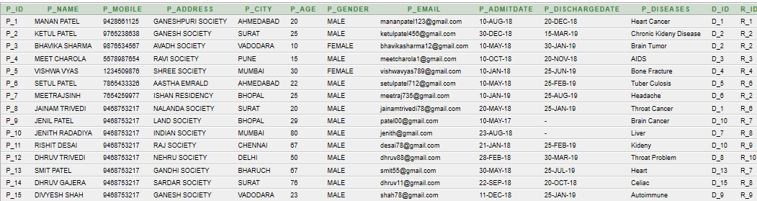

1. DOCTOR:

INSERT INTO Doctor

VALUES('D_1','DEEP SHARMA',9428661121,'RAM SOCIETY','deepsharma@gmail.com',29,'MALE',100000,'CANCER SPECIALIST','10-AUG-2019');

INSERT INTO Doctor

VALUES('D_2','SWEETY PATEL',7667436288,'RAMSITA SOCIETY','sweetypatel@gmail.com',26,'FEMALE',250000,'KIDENY SPECIALIST','10-JAN-2019')

;

INSERT INTO Doctor

VALUES('D_3','MEET PATEL',2234568765,'RAMSITA SOCIETY','meetpatel456@gmail.com',25,'MALE',700000,'MBBS,MS','10-JAN-2019');

INSERT INTO Doctor

VALUES('D_4','FRANCY PATEL',5678907658,'RAVI SOCIETY','francypatel653@gmail.com',23,'FEMALE',600000,'MBBS,MD','10-SEP-2019');

INSERT INTO Doctor

VALUES('D_5','KRINA GUPTA',5678998765,'AVADH SOCIETY','krinagupta789@gmail.com',25,'FEMALE',400000,'MBBS,MS','10-FEB-2019');

INSERT INTO Doctor

VALUES('D_6','VIRAT KOHLI',6464854654,'HEAVEN CITY','viratkohli18@gmail.com',30,'MALE',10000000,'MD,DM','10-JUL-2019');

INSERT INTO Doctor

VALUES('D_7','SWATI PATEL',8520147963,'HEAVEN CITY','swati18@gmail.com',25,'FEMALE',100700,'MD,DM','07-FEB-2019');

INSERT INTO Doctor

VALUES('D_8','RAJAN RAHANI',9988221166,'RAJAPURI SOCIETY','rajan12@gmail.com',50,'MALE',800000,'MD,DM','10-JAN-2000');

INSERT INTO Doctor

VALUES('D_9','DARSHIT THIMAR',9125863247,'HEAVEN CITY','thimar34@gmail.com',45,'MALE',200000,'MD,DM','19-JUL-2011');

INSERT INTO Doctor

VALUES('D_10','VATSAL KUMAR',7531596248,'RAJ SOCIETY','kumar555@gmail.com',33,'MALE',180000,'MULTI SPECIALIST','30-JUL-2019');

INSERT INTO Doctor

VALUES('D_11','NISHAG SHAH',8520369741,'ALPITA CITY','nisarg000@gmail.com',40,'MALE',160000,'MD,DM','22-DEC-2010');

INSERT INTO Doctor

VALUES('D_12','VISHWA KOHLI',9512368740,'GOLDENCITY','vishwa18@gmail.com',38,'FEMALE',10800,'MD,DM','27-JUN-2015');

INSERT INTO Doctor

VALUES('D_13','DEVESH RAY',3562147890,'HEAVEN CITY','ray18@gmail.com',32,'MALE',100555,'MBBS','11-OCT-2019');

INSERT INTO Doctor

VALUES('D_14','DHAIRYA DAGALI',6464854688,'GULMARG CITY','sachin18@gmail.com',30,'MALE',200000,'MD,DM','30-JUL-2019');

INSERT INTO Doctor

VALUES('D_15','DIP TADVI',6464854888,'ASHIYANA CITY','tadvi18@gmail.com',50,'MALE',100000,'MBBS','19-AUG-2000');

SELECT *FROM DOCTOR

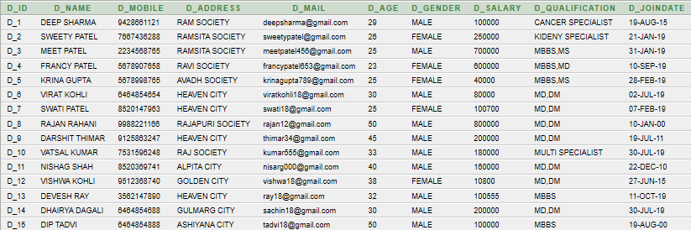

3. ROOMS:

INSERT INTO Rooms

VALUES('R_1','DELUXE',1,5500);

INSERT INTO Rooms

VALUES('R_2','GENERAL',3,700);

INSERT INTO Room

VALUES('R_3','AC ROOM',2,4500)

INSERT INTO Rooms

VALUES('R_4','NONAC ROOM',1500),;

INSERT INTO Rooms

VALUES('R_5','DELUXE',3,5500);

INSERT INTO Rooms

VALUES('R_6','GENERAL',2,700);

INSERT INTO Rooms

VALUES('R_7','DELUXE',3,5500);

INSERT INTO Rooms

VALUES('R_8',AC ROOM ',1,4500);

INSERT INTO Rooms

VALUES('R_9','NONAC ROOM',2,1500);

INSERT INTO Rooms

VALUES('R_10','GENERAL',3,700);

SELECT *FROM ROOMS

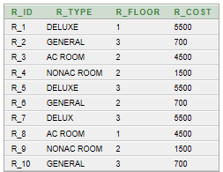

4. BILLS:

INSERT INTO Bills

VALUES('A_1','P_1');

INSERT INTO Bills

VALUES('A_2','P_1');

INSERT INTO Bills

VALUES('A_3','P_2');

INSERT INTO Bills

VALUES('A_4','P_3');

INSERT INTO Bills

VALUES('A_5','P_4');

INSERT INTO Bills

VALUES('A_6','P_3');

INSERT INTO Bills

VALUES('A_7','P_4');

INSERT INTO Bills

VALUES('A_8','P_5');

INSERT INTO Bills

VALUES('A_9','P_6');

INSERT INTO Bills

VALUES('A_10','P_7');

INSERT INTO Bills

VALUES('A_11','P_8');

INSERT INTO Bills

VALUES('A_12','P_9');

INSERT INTO Bills

VALUES('A_13','P_10');

INSERT INTO Bills

VALUES('A_14','P_11');

INSERT INTO Bills

VALUES('A_15','P_12');

INSERT INTO Bills

VALUES('A_16','P_13');

INSERT INTO Bills

VALUES('A_17','P_14');

INSERT INTO Bills

VALUES('A_18','P_15');

SELECT *FROM BILLS

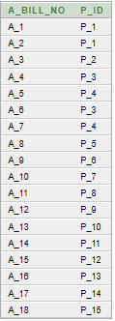

5. EMPLOYEE:

INSERT INTO Employee

VALUES('E_1','KETUL PATEL',1234567890,'AASTHA EMRALD',19,'MALE',40000,'10-JAN-2010','');

INSERT INTO Employee

VALUES('E_2','SALONI PATEL',5678267890,'AVADH SOCIETY',30,'FEMALE',28000,'12-JAN-2015','');

INSERT INTO Employee

VALUES('E_3','ABHISHEK PATEL',1237665490,'RAM SOCIETY',30,'MALE',30000,'20-DEC-2019','');

INSERT INTO Employee

VALUES('E_4','PRACHI CHAUDHARI',9876543210,'RAMSITA SOCIETY',30,'FEMALE',21000,'25-FEB-2019','');

INSERT INTO Employee

VALUES('E_5','SMIT SAVANI',9876543873,'RAVI SOCIETY',20,'MALE',20000,'05-AUG-2011','');

INSERT INTO Employee

VALUES('E_6','DIP SIDPARA',4566597788,'RAMLAKHAN SOCITEY',25,'MALE',18000,'19-MAY-2016','');

INSERT INTO Employee

VALUES('E_7','MANAN PATEL',3546778997,'GUMNAM SOCIETY',26,'MALE',19000,'25-NOV-2013','');

INSERT INTO Employee

VALUES('E_8','VIVEK PARIKH',8534695721,'BHAVNA SOCIETY',20,'MALE',29000,'25-MAY-2019','');

INSERT INTO Employee

VALUES('E_9','DIVYAM SOLANKI',8547961235,'RAVI SOCIETY',36,'MALE',59000,'25-FEB-2018','');

INSERT INTO Employee

VALUES('E_10','PARTH PARMAR',9874521360,'ROYAL SOCIETY',36,'MALE',32000,'25-JAN-2009','');

INSERT INTO Employee

VALUES('E_11','AAYUSH RAYANI',9966225588,'BLOSSEM SOCIETY',56,'MALE',11000,'25-DEC-2000','');

INSERT INTO Employee

VALUES('E_12','MOHIT PRAJAPATI',6655221144,'RAJ SOCIETY',45,'MALE',14000,'25-NOV-2006','');

INSERT INTO Employee

VALUES('E_13','HARSHIL RAVAL',4488557799,'KAMAL SOCIETY',32,'MALE',13000,'25-NOV-2003','');

INSERT INTO Employee

VALUES('E_14','DAXES PARMAR',4567845678,'AMIR SOCIETY',29,'MALE',12000,'25-AUG-2013','');

INSERT INTO Employee

VALUES('E_15','HARSHRANA',3546755662,'GARIBSOCIETY',43,'MALE',19000,'25-SEP-2011','');

SELECT *FROM EMPLOYEE

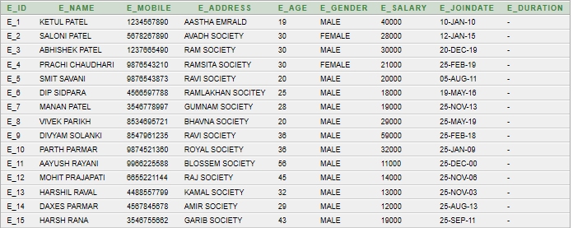

6. ACCOUNTS:

INSERT INTO Accounts

VALUES('A_1','20-AUG-2019','','');

INSERT INTO Accounts

VALUES('A_2','30-AUG-2019','','');

INSERT INTO Accounts

VALUES('A_3','16-MAY-2019','','');

INSERT INTO Accounts

VALUES('A_4','18-JAN-2019','','');

INSERT INTO Accounts

VALUES('A_5','30-MAR-2019','','');

INSERT INTO Accounts

VALUES('A_6','30-JAN-2019','','');

INSERT INTO Accounts

VALUES('A_7','27-JUN-2019','','');

INSERT INTO Accounts

VALUES('A_8','30-JUL-2019','','');

INSERT INTO Accounts

VALUES('A_9','10-FEB-2019','','');

INSERT INTO Accounts

VALUES('A_10','12-APR-2019','','');

INSERT INTO Accounts

VALUES('A_11','20-MAY-2019','','');

INSERT INTO Accounts

VALUES('A_12','20-MAY-2019','','');

INSERT INTO Accounts

VALUES('A_13','20-MAY-2019','','');

INSERT INTO Accounts

VALUES('A_14','25-FEB-2019','','');

INSERT INTO Accounts

VALUES('A_15','30-MAR-2019','','');

INSERT INTO Accounts

VALUES('A_16','25-JUL-2019','','');

INSERT INTO Accounts

VALUES('A_17','20-OCT-2018','','');

INSERT INTO Accounts

VALUES('A_18','26-JAN-2019','','');

SELECT *FROM ACCOUNTS 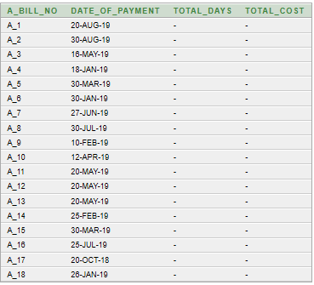

7. WORKS_IN:

INSERT INTO WORKS_IN

VALUES('R_1','E_5');

INSERT INTO WORKS_IN

VALUES('R_2','E_1');

INSERT INTO WORKS_IN

VALUES('R_3','E_2');

INSERT INTO WORKS_IN

VALUES('R_2','E_5');

INSERT INTO WORKS_IN

VALUES('R_6','E_4');

INSERT INTO WORKS_IN

VALUES('R_6','E_7');

INSERT INTO WORKS_IN

VALUES('R_4','E_2');

INSERT INTO WORKS_IN

VALUES('R_7','E_8');

INSERT INTO WORKS_IN

VALUES('R_8','E_9');

INSERT INTO WORKS_IN

VALUES('R_9','E_10');

INSERT INTO WORKS_IN

VALUES('R_10','E_11');

INSERT INTO WORKS_IN

VALUES('R_7','E_12');

INSERT INTO WORKS_IN

VALUES('R_8','E_13');

INSERT INTO WORKS_IN

VALUES('R_9','E_14');

SELECT *FROM WORKS_IN

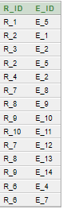

**5.3 QUERIES:**

1. DISPLAY THE DOCTOR NAME AND THE DOCTOR ADDRESS WHICH ARE TREATING THE PATIENT WHICH ARE LEAVING IN THE CITY AHMEDBAD.

SELECT D_NAME,D_ADDRESS FROM DOCTOR INNER JOIN PATIENT ON PATIENT.D_ID=DOCTOR.D_ID WHERE P_CITY=’AHMEDABAD’

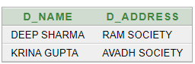

1. DISPLAY THE PATIENT NAME AND THE ADDRESS WHO ARE ADMITTED IN THE GENERAL COMPOUND OF THE HOSPITAL LOCATE AT THE SECOND FLOOR.

SELECT P_NAME,P_ADDRESS FROM PATIENT INNER JOIN ROOMS ON PATIENT.R_ID=ROOMS.R_ID WHERE R_TYPE=’GENERAL’ AND R_FLOOR=2

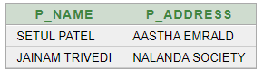

1. DISPLAY THE PATIENT ID AND PATIENT ADDRESS WHICH ARE ADMITTED IN THE YEAR 2018 AND DISCHARGED IN THE YEAR 2019.

SELECT P_ID, P_NAME,EXTRACT(YEAR FROM P_ADMITDATE) AS P_ADMITDATE ,EXTRACT(YEAR FROM P_DISCHARGEDATE) AS P_DISCHAGREDATE FROM PATIENT WHERE P_ADMITDATE<=’31-DEC-2018 AND P_ADMITDATE>=’01-JAN-2018’ AND P_DISCHARGEDATE <=’31-DEC-2019’ AND P_DISCHARGEDATE>=’01-JAN-2019’

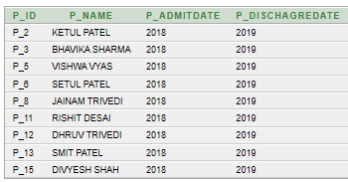

1. COUNT THE TOTAL NUMBER OF MALE AND FEMALE PATIENT ADMITTED IN THE HOSPITAL.

SELECT COUNT(P_ID),P_GENDER FROM PATIENT GROUP BY P_GENDER

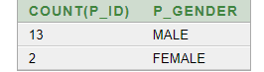

1. DISPLAY THE EMPLOYEE NAMES WHO ARE WORKING IN THE GENERAL COMPOUND.

SELECT E_NAME FROM EMPLOYEE INNER JOIN WORKS_IN ON EMPLOYEE.E_ID=WORKS_IN.E_ID INNER JOIN ROOMS ON WORKS_IN.R_ID=ROOMS.R_ID WHERE R_TYPE=’GENERAL’

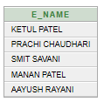

1. COUNT THE TOTAL NUMBER OF THE DOCTOR HAVING SALARY GREATER THAN OR EQUAL TO 2.5 LAKHS.

SELECT COUNT(D_ID) FROM DOCTOR WHERE D_SALARY>=250000

Screenshot (36).png

1. DISPLAY THE PATIENT NAMES IN THE DESCENDING ORDER.

SELECT *FROM PATIENT ORDER BY P_NAME DESC

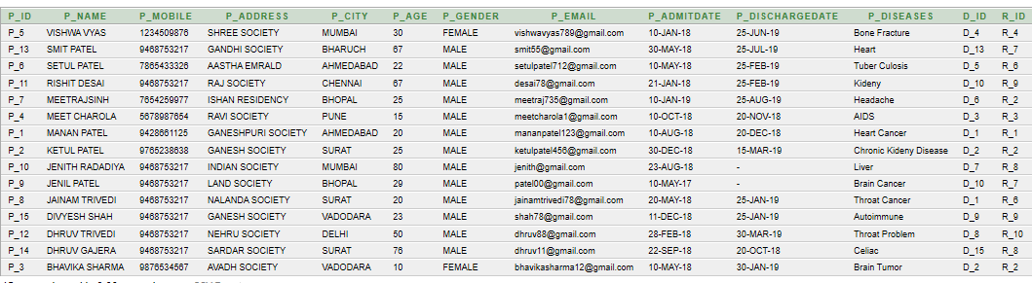

1. COUNT THE TOTAL NUMBER OF THE EMPLOYEES WHICH ARE NOT WORKING IN THE GENERAL COMPOUND.

SELECT COUNT(E_ID) FROM WORKS_IN

WHERE R_ID IN

(

SELECT R_ID FROM ROOMS WHERE R_TYPE<>'GENERAL'

)

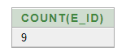

1. COUNT THE TOTAL NUMBER OF THE PATIENT WHICH ARE ADMITTED IN THE LAST 15 MONTHS UNDER THE Dr.GANESH PATEL.



1. DISPLAY THE PATIENT NAMES WHICH ARE CURED BY THE MALE DOCTORS.

SELECT P_NAME FROM PATIENT WHERE

D_ID IN

(

SELECT D_ID FROM PATIENT

WHERE D_ID IN

(

SELECT D_ID FROM DOCTOR WHERE D_GENDER='MALE'

)

)

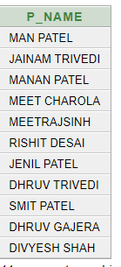

**5.4 EXCEPTION:**

1. DISPLAY THE SALARY OF DOCTOR WHICH ID IS GIVEN BY USER.

DECLARE

SAL NUMBER(10);

DID VARCHAR(10);

BEGIN

DID:=:DID;

SELECT D_SALARY INTO SAL FROM DOCTOR

WHERE D_ID=DID;

DBMS_OUTPUT.PUT_LINE('SALARY OF DOCTOR IS : '||SAL);

EXCEPTION

WHEN NO_DATA_FOUND THEN

DBMS_OUTPUT.PUT_LINE('DATA NOT AVAILABLE IN YOUR TABLE');

END;

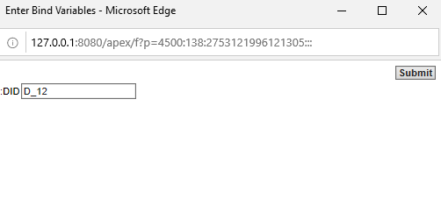

Screenshot (42).png

1. ENTER THE DATE AND CONFIRM THAT ON THIS DATE WHICH PATIENT WAS ADMITED.

DECLARE

PD DATE;

HELLO EXCEPTION;

TYPE TEMP_1 IS TABLE OF PATIENT.P_ID%TYPE;

TEMP TEMP_1;

BEGIN

PD:=:ADMIT_DATE_IS;

SELECT P_ID BULK COLLECT INTO TEMP FROM PATIENT WHERE P_ADMITDATE=PD;

FOR I IN TEMP.FIRST..TEMP.LAST

LOOP

DBMS_OUTPUT.PUT_LINE('PATIENT ID IS '||TEMP(I));

END LOOP;

EXCEPTION

WHEN HELLO THEN

DBMS_OUTPUT.PUT_LINE('ON THIS DATE NO PATIENT WERE ADMITED.');

END;

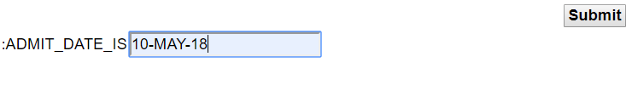

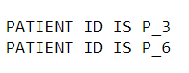

* 1. **FUNCTIONS:**

1) CREATE A FUNCTION THAT DISPLAY THE NAME OF THE DOCTOR WHOSE SLARAY IS THE PARTICULAR HIGHEST NUMBER SALARY WHERE THE HIGHEST NUMBER IS GIVEN BY USER.

CREATE OR REPLACE FUNCTION FF(D1 IN NUMBER)

RETURN VARCHAR IS

EID VARCHAR(20);

BEGIN

SELECT D_NAME INTO EID

FROM

(SELECT D_NAME FROM (SELECT DISTINCT D_SALARY,D_NAME FROM DOCTOR ORDER BY D_SALARY DESC)

WHERE ROWNUM<=D1

MINUS

SELECT D_NAME FROM(SELECT DISTINCT D_SALARY,D_NAME FROM DOCTOR ORDER BY D_SALARY DESC)

WHERE ROWNUM<=D1-1);

RETURN EID;

END;

DECLARE

A VARCHAR(20);

B NUMBER(2);

BEGIN

B:= :B;

A:= FF(B);

DBMS_OUTPUT.PUT_LINE('THE DOCTOR NAME IS '||A);

END;



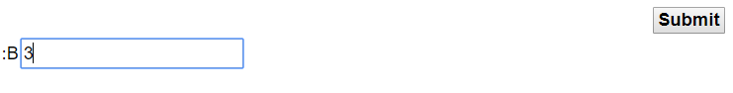

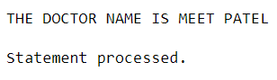

2) COUNT TOTAL NO. OF DOCTOR WHO WERE JOIN BEFORE '25-AUG-2018' AND SALARY IS GREATER THAN 100000.

CREATE OR REPLACE FUNCTION FD1(D1 IN DATE,D2 IN NUMBER)

RETURN NUMBER IS

NUMB NUMBER;

BEGIN

SELECT COUNT(D_ID) INTO NUMB FROM DOCTOR WHERE D_JOINDATE<D1 AND D_SALARY>D2;

DBMS_OUTPUT.PUT_LINE('TOTAL NO. OF DOCTOR IS');

RETURN NUMB;

END;

SELECT FD('25-AUG-2018',100000) FROM DUAL

Screenshot (47).png

* 1. **PROCEDURES:**

1) CREATE A PROCEDURE TO ADD NEW PATIENT IN DETAILS.

CREATE OR REPLACE PROCEDURE INSERT_INTO(P IN PATIENT.P_ID%TYPE,PC IN PATIENT.P_NAME%TYPE,PM IN PATIENT.P_MOBILE%TYPE,PA IN PATIENT.P_ADDRESS%TYPE,PCI IN PATIENT.P_CITY%TYPE,PAG IN PATIENT.P_AGE%TYPE,PG IN PATIENT.P_GENDER%TYPE,PE IN PATIENT.P_EMAIL%TYPE,PAD IN PATIENT.P_ADMITDATE%TYPE,PDD IN PATIENT.P_DI

CHARGEDATE%TYPE,PD IN PATIENT.P_DISEASES%TYPE,DD IN PATIENT.D_ID%TYPE,R IN PATIENT.R_ID%TYPE) IS

BEGIN

INSERT INTO

PATIENT("P_ID","P_NAME","P_MOBILE","P_ADDRESS","P_CITY","P_AGE","P_GENDER","P_EMAIL","P_ADMITDATE","P_DICHARGEDATE","P_DISEASES","D_ID","R_ID")VALUES(P,PC,PM,PA,PCI,PAG,PG,PE,PAD,PDD,PD,DD,R);

END;

DECLARE

A PATIENT.P_ID%TYPE;

B PATIENT.P_NAME%TYPE;

C PATIENT.P_MOBILE%TYPE;

D PATIENT.P_ADDRESS%TYPE;

E PATIENT.P_CITY%TYPE;

F PATIENT.P_AGE%TYPE;

G PATIENT.P_GENDER%TYPE;

H PATIENT.P_EMAIL%TYPE;

I PATIENT.P_ADMITDATE%TYPE;

J PATIENT.P_DICHARGEDATE%TYPE;

K PATIENT.P_DISEASES%TYPE;

L PATIENT.D_ID%TYPE;

M PATIENT.R_ID%TYPE;

BEGIN

A:=:P_ID;

B:=:P_NAME;

C:=:P_MOBILE;

D:=:P_ADDRESS;

E:=:P_CITY;

F:=:P_AGE;

G:=:P_GENDER;

H:=:P_EMAIL;

I:=:P_ADMITDATE;

J:=:P_DICHARGEDATE;

K:=:P_DISEASES;

L:=:D_ID;

M:=:R_ID;

INSERT_INTO(A,B,C,D,E,F,G,H,I,J,K,L,M);

END;

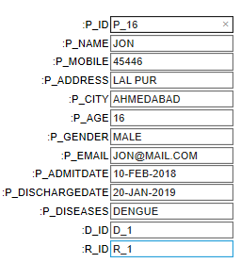

SELECT *FROM PATIENT

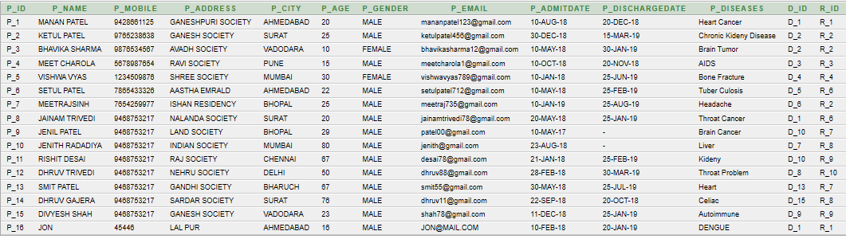

2) CREATE A PROCEDURE TO DISPLAY IN WHICH ROOM EMPLOYEE WORKS.

CREATE OR REPLACE PROCEDURE P1(NAME IN EMPLOYEE.E_ID%TYPE)

IS

TYPE TEMP_1 IS TABLE OF WORKS_IN.R_ID%TYPE;

TEMP TEMP_1;

AA NUMBER(20);

BEGIN

SELECT COUNT(R_ID) INTO AA FROM WORKS_IN;

SELECT R_ID BULK COLLECT INTO TEMP FROM WORKS_IN WHERE E_ID=NAME;

FOR I IN TEMP.FIRST..TEMP.LAST

LOOP

DBMS_OUTPUT.PUT_LINE('EMPLOYEE '||NAME|| 'WORKS IN '||TEMP(I));

END LOOP;

END;

DECLARE

NA EMPLOYEE.E_ID%TYPE;

BEGIN

NA:=:ENETR_THE_EMPLOYEE_ID;

P1(NA);

END;



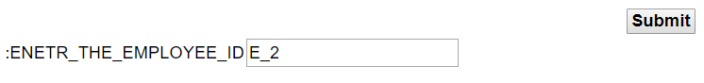

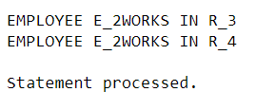

**5.7 TRIGGERS:**

1. CREATE A TRIGGER SYSTEM FOR THE TABLE DOCTOR. IF THE DOCTOR AGE IS GREATER WHILE INSERTING OR UPDATING THAN THE 45 INSERT INTO OLD_DOCTOR TABLE OTHERWISE ENTER INTO TO NEW_DOCTOR TABLE.

CREATE OR REPLACE TRIGGER D_UP1 AFTER INSERT ON DOCTOR FOR EACH ROW

DECLARE

AGE NUMBER;

BEGIN

AGE:=:NEW.D_AGE;

IF (AGE<45) THEN

INSERT INTO YOUNG_DOCTOR VALUES(:NEW.D_ID,:NEW.D_NAME,:NEW.D_MOBILE,:NEW.D_ADDRESS,:NEW.D_MAIL,:NEW.D_AGE,:NEW.D_GENDER,:NEW.D_SALARY,:NEW.D_QUALIFICATION,:NEW.D_JOINDATE);

ELSIF (AGE>45) THEN

INSERT INTO OLD_DOCTOR VALUES(:NEW.D_ID,:NEW.D_NAME,:NEW.D_MOBILE,:NEW.D_ADDRESS,:NEW.D_MAIL,:NEW.D_AGE,:NEW.D_GENDER,:NEW.D_SALARY,:NEW.D_QUALIFICATION,:NEW.D_JOINDATE);

END IF;

END;

Capture3.PNG

INSERT INTO Doctor

VALUES('D_20','DEEP SHARMA',9428661121,'RAM SOCIETY','deepsharma@gmail.com',29,'MALE',100000,'CANCER SPECIALIST','10-AUG-2019');

SELECT *FROM YOUNG_DOCTOR

Capture5.PNG

INSERT INTO Doctor

VALUES('D_21','DEEP SHARMA',9428661121,'RAM SOCIETY','deepsharma@gmail.com',49,'MALE',100000,'CANCER SPECIALIST','10-AUG-2019');

SELECT *FROM OLD_DOCTOR

Capture6.PNG

UPDATE DOCTOR SET D_AGE='50' WHERE D_ID='D_1'

SELECT *FROM OLD_DOCTOR

Capture8.PNG

1. CREATE A TRIGGER SYSTEM FOR THE TABLE PATIENT. THE SYSTEM MUST KEEP THE TRACK OF RECORDS THAT ARE BEING UPDATED IN THE PATIENT TABLE, IF THE PATIENTS ARE FROM AHMEDABAD, BHARUCH OR SURAT CITY THEY SHOULD BE IN SPERATE TABLE AND OTHERS IN THE OTHERS**.**

CREATE OR REPLACE TRIGGER P_DUP1 AFTER UPDATE ON PATIENT FOR EACH ROW

DECLARE

P VARCHAR2 (20);

BEGIN

P:=:OLD.P_CITY;

IF (P='AHMEDABAD') THEN

INSERT INTO PATIENT_AHMEDABAD VALUES(:OLD.P_ID,:OLD.P_NAME,:OLD.P_MOBILE,:OLD.P_ADDRESS,:OLD.P_CITY,:OLD.P_AGE,:OLD.P_GENDER,:OLD.P_EMAIL,:OLD.P_ADMITDATE,:OLD.P_DISCHARGEDATE,:OLD.P_DISEASES,:OLD.D_ID,:OLD.R_ID);

ELSIF (P='BHARUCH') THEN

INSERT INTO PATIENT_BHARUCH VALUES(:OLD.P_ID,:OLD.P_NAME,:OLD.P_MOBILE,:OLD.P_ADDRESS,:OLD.P_CITY,:OLD.P_AGE,:OLD.P_GENDER,:OLD.P_EMAIL,:OLD.P_ADMITDATE,:OLD.P_DISCHARGEDATE,:OLD.P_DISEASES,:OLD.D_ID,:OLD.R_ID);

ELSIF (P='SURAT') THEN

INSERT INTO PATIENT_SURAT VALUES(:OLD.P_ID,:OLD.P_NAME,:OLD.P_MOBILE,:OLD.P_ADDRESS,:OLD.P_CITY,:OLD.P_AGE,:OLD.P_GENDER,:OLD.P_EMAIL,:OLD.P_ADMITDATE,:OLD.P_DISCHARGEDATE,:OLD.P_DISEASES,:OLD.D_ID,:OLD.R_ID);

ELSE

INSERT INTO PATIENT_OTHER VALUES(:OLD.P_ID,:OLD.P_NAME,:OLD.P_MOBILE,:OLD.P_ADDRESS,:OLD.P_CITY,:OLD.P_AGE,:OLD.P_GENDER,:OLD.P_EMAIL,:OLD.P_ADMITDATE,:OLD.P_DISCHARGEDATE,:OLD.P_DISEASES,:OLD.D_ID,:OLD.R_ID);

END IF;

END;

Capture3.PNG

UPDATE PATIENT SET P_CITY='SURAT' WHERE P_CITY='AHMEDABAD'

1.PNG

SELECT *FROM PATIENT_SURAT



**5.8 CURSORS:**

1. GIVE DIWALI BONUS TO ALL EPMLOYEE 10% OF HIS/HER SALARY.

DECLARE A NUMBER(10);

BEGIN

UPDATE EMPLOYEE SET E_SALARY=E_SALARY+ E_SALARY*0.1;

IF SQL%NOTFOUND THEN

DBMS_OUTPUT.PUT_LINE('NO UPDATE');

ELSIF SQL%FOUND THEN

A:=SQL%ROWCOUNT;

DBMS_OUTPUT.PUT_LINE('SALARY OF'||A||' EMPLOYEES ARE UPDATED');

END IF;

END;

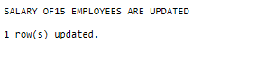

1. GIVE THE PATIENT NAME, PATIENT ID AND DOCTOR NAME WHOSE MONTH DIFFERENCE OF PATIENT ADMITDATE AND DOCTOR JOINDATE IS GREATER THAN 12 MONTHS.

DECLARE CURSOR INFO IS SELECT P.P_ID,P.P_NAME,P.D_ID FROM PATIENT P INNER JOIN DOCTOR D ON P.D_ID=D.D_ID WHERE MONTHS_BETWEEN(D.D_JOINDATE,P.P_ADMITDATE)>12;

DUMMYPID VARCHAR(20);

DUMMYNAME VARCHAR(20);

DUMMYDID VARCHAR(20);

BEGIN

OPEN INFO;

IF INFO%ISOPEN THEN

LOOP

DBMS_OUTPUT.PUT_LINE('PATIENT ID '||DUMMYPID||' & PATIENT NAME '||DUMMYNAME||' & DOCTOR ID '||DUMMYDID);

FETCH INFO INTO DUMMYPID,DUMMYNAME,DUMMYDID;

EXIT WHEN INFO%NOTFOUND;

END LOOP;

END IF;

CLOSE INFO;

END;

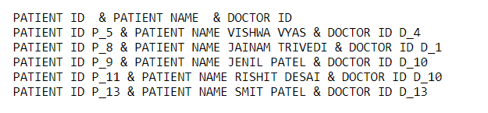

**6. FUTURE ENHANCEMENTS OF THE SYSTEM**

* The whole project is the how the particular hospital can have their database related to the hospital detailed information. The hospital database contains the information about the doctors, patients, rooms and employee details.
* Sometimes it has seen than the hospital want to access the particular patient detail, so in that case if we have the database of the hospital then we can get information about the patient/doctor or entity thing which is related to the hospital.
* It is necessary for the hospital to keep the information about the doctors/employees who are working in the hospitals, as the particular doctor should be called for the particular patient and particular employee is working for the particular employees, it is easy to get information about that using the database of the hospital.
* In future if we want to count the number of patient admitted and in addition how much patient of the particular diseases have been admitted and all such information can be stored in the database and can be used when we want to see the information.
* Ultimate goal of the system is to collect the information which are related to the hospital so they can be accessed when we want to find some information about the particular hospital.
* **BIBLIOGRAPHY**
* THE COMPLETE REFERENCE BY :- GEORGE KOCH
* PL/SQL PROGRAMMING BY :- IVAN BAYROSS
* DATABASE SYSTEM CONCEPTS

BY:- HENRY F.KORTH AND A.SILBERSCHATZ